Aim: Design and develop an interactive user interface using React.

Code:

App.js

import { useState, useCallback } from "react";
import "./App.css";

function Calculator() {
const [display, setDisplay] = useState("0");
const [prev, setPrev] = useState(null);
const [op, setOp] = useState(null);
const [resetNext, setResetNext] = useState(false);
const [expr, setExpr] = useState("");

const inputDigit = useCallback(
(d) => {
setDisplay((cur) => {
if (resetNext) {
setResetNext(false);
return String(d);
}
if (cur === "0") return String(d);
if (cur.length >= 12) return cur;
return cur + d;
});
},
[resetNext]
);

const inputDot = useCallback(() => {
setDisplay((cur) => {
if (resetNext) {
setResetNext(false);
return "0.";
}
if (cur.includes(".")) return cur;
return cur + ".";
});
}, [resetNext]);

const calculate = (a, b, operator) => {
switch (operator) {
case "+": return a + b;
case "−": return a - b;
case "×": return a * b;
case "÷": return b === 0 ? "Error" : a / b;
case "%": return a % b;
default: return b;
}
};

const inputOp = useCallback(
(nextOp) => {
const cur = parseFloat(display);
if (prev !== null && !resetNext) {
const result = calculate(prev, cur, op);
const rounded = parseFloat(result.toFixed(10));
setDisplay(String(rounded));
setPrev(rounded);
setExpr(String(rounded) + " " + nextOp);
} else {
setPrev(cur);
setExpr(display + " " + nextOp);
}
setOp(nextOp);
setResetNext(true);
},
[display, prev, op, resetNext]
);

const equals = useCallback(() => {
if (op === null || prev === null) return;
const cur = parseFloat(display);
const result = calculate(prev, cur, op);
const rounded =
result === "Error" ? "Error" : parseFloat(result.toFixed(10));
setExpr(expr + " " + display + " =");
setDisplay(String(rounded));
setPrev(null);
setOp(null);
setResetNext(true);
}, [display, prev, op, expr]);

const clear = () => { setDisplay("0"); setPrev(null); setOp(null); setResetNext(false); setExpr(""); };
const toggleSign = () => setDisplay((d) => (d === "0" ? "0" : d.startsWith("-") ? d.slice(1) : "-" + d));
const percent = () => setDisplay((d) => String(parseFloat(d) / 100));
const backspace = () => setDisplay((d) => (d.length > 1 ? d.slice(0, -1) : "0"));

const buttons = [
{ label: "AC", action: clear, type: "func" },
{ label: "+/−", action: toggleSign, type: "func" },
{ label: "%", action: percent, type: "func" },
{ label: "÷", action: () => inputOp("÷"), type: "op" },
{ label: "7", action: () => inputDigit(7), type: "num" },
{ label: "8", action: () => inputDigit(8), type: "num" },
{ label: "9", action: () => inputDigit(9), type: "num" },
{ label: "×", action: () => inputOp("×"), type: "op" },
{ label: "4", action: () => inputDigit(4), type: "num" },
{ label: "5", action: () => inputDigit(5), type: "num" },
{ label: "6", action: () => inputDigit(6), type: "num" },
{ label: "−", action: () => inputOp("−"), type: "op" },
{ label: "1", action: () => inputDigit(1), type: "num" },
{ label: "2", action: () => inputDigit(2), type: "num" },
{ label: "3", action: () => inputDigit(3), type: "num" },
{ label: "+", action: () => inputOp("+"), type: "op" },
{ label: "⌫", action: backspace, type: "num" },
{ label: "0", action: () => inputDigit(0), type: "num" },
{ label: ".", action: inputDot, type: "num" },
{ label: "=", action: equals, type: "eq" },
];

const displayLen = display.replace("-", "").replace(".", "").length;
const fontSize =
displayLen > 10 ? "1.6rem" : displayLen > 7 ? "2rem" : "2.6rem";

return (
<div className="calc-wrapper">
<div className="calculator">
{/* Display */}
<div className="display">
<div className="expression">{expr || "\u00A0"}</div>
<div className="number" style={{ fontSize }}>
{display}
</div>
</div>

{/* Buttons */}
<div className="buttons">
{buttons.map((btn, i) => (
<button
key={i}
className={`btn btn-${btn.type} ${btn.label === op ? "active-op" : ""}`}
onClick={btn.action}
>
{btn.label}
</button>
))}
</div>
</div>
</div>
);
}

export default Calculator;
Output:

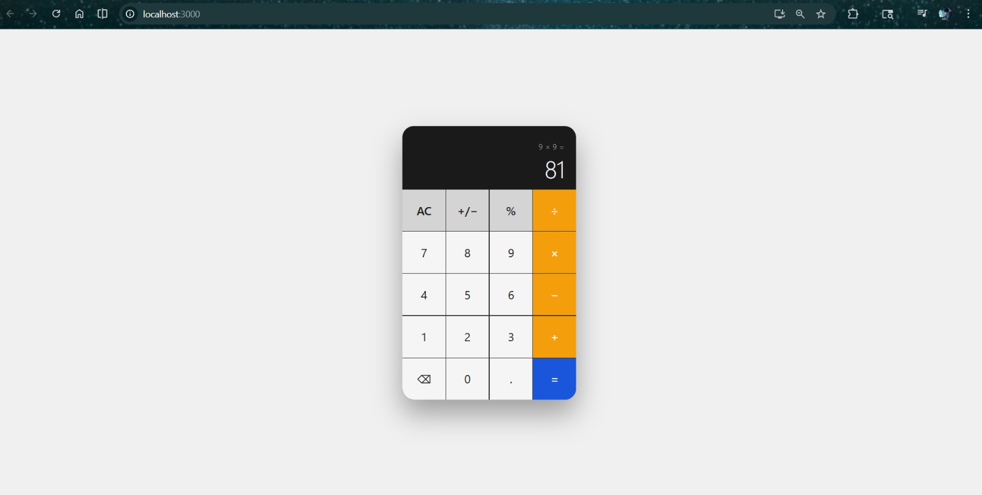

FAQ:

